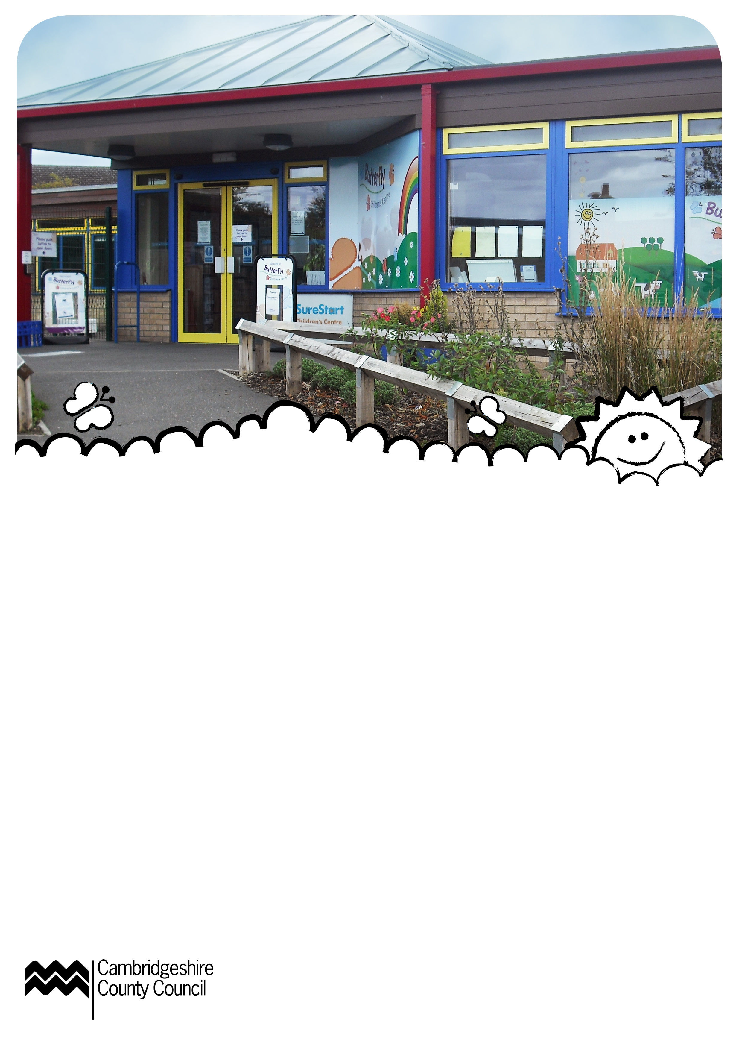
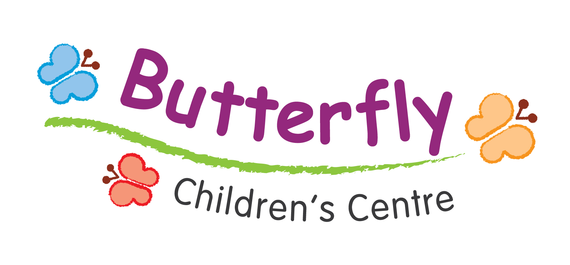

What’s On
September 2012
Opening times
Monday – Thursday 8.45-4.30pm
Friday 8.45-1.00pm
What is a Children’s Centre?
Children’s Centres support all families with children under five. We offer easier access to health and family support, help with finding jobs, and training, drop-in sessions and activities and information about local childcare and early education.
Monday

Pop-in & Play
10.00-12.00noon
Craft activities, songs and rhymes. Run by NCT volunteers.
Baby Mucky Pups
2.00-3.00pm
A chance for babies to explore their senses and get messy. For pre-walking babies from six months old.
Evening Childminder Group
7.30-9.00pm
17 September
Support group for local childminders.
Tuesday
Puffins
9.30-11.00am
Additional needs group. Referrals only – please ask for details.
Speech & Language Drop-in
9.30-11.30am
25 September
Do you have any questions about your child’s speech? Drop-in for a chat with a qualified Speech and Language Therapist.
Booking essential for all sessions marked with a *
Young Parents Group
1.00-3.00pm
Drop-in group for parents 23
and under with their children.
Baby Massage*
10.30-11.30am
4, 11, 18 and 25 September
Four sessions for pre-crawling babies.
Bargroves, Cromwell Road
Wednesday
Zoo Lab*
10.30-11.30am
12 September
Come along to our one off mini beast workshops. You will be able to meet a selection of tropical animals and learn facts about them.
Confidence Course*
1.00-2.30pm
Starting 19 September
10 week course allowing parents
to build up their confidence and become more assertive.
Crèche available.
Leaps and Bounds*
10.00-10.45am
Starting 5 September
Six sessions to help develop motor and movement skills as well as helping to increase their confidence.
For children 2 – under 5 years
Bargroves, Cromwell Road.
Relax and Breathe*

12.45-2.15pm
5, 12 and 19 September
St. Mary’s Primary School, Wintringham Road.
Weaning Talk and Demonstration*
1.00-2.30pm
5 September
Advice and ideas on weaning.
Baby Clinic
1.30-3.00pm
12 and 26 September
Come along to have your baby weighed, speak to a Health Visitor
and a chance to play.
International Afternoon*
2.00-4.00pm
19 September
Come and join in our fun interactive session with craft activities. Everyone helps prepare a snack. This month the country we are discovering is Canada.
Thursday
Mucky Pups
9.30-11.30am
Arts, crafts and messy play.
Luminus Housing Advice
10.00-11.00am
13 September
Drop in for advice and information on housing.
JobCentrePlus Drop-In
10.45-12.30pm
6 September
Drop-in for information and advice about getting back into work.
BabyCalm*
12.30-2.30pm
6, 13, 20 and 27 September
For babies from birth up to 20 weeks old.
Child Safety Fun Day!
1.00-2.30pm
6 September
Come along and learn more about child safety. There will be an interactive visit from emergency services, craft activities and games. Why not bring a picnic! Open to the whole family.
St. Neots Riverside Park (behind the Ambience Café)
ESOL*
12.30-2.30pm
Starting 20 September
Ten sessions to help you learn and improve your English.
Offsite crèche available –
please ask for details.
Facilitated by Family Learning.
Bargroves, Cromwell Road
All sessions are for children
under 5 unless stated otherwise.

Friday
Bouncers
9.30-10.30am
Active indoor play session. For children from walking to under 5.
Bargroves, Cromwell Road
Stay & Play
10.30-12.30pm
Drop in and play.
Adult Numeracy*
9.30-11.30am
Starting 21 September
30 week course designed to help you improve your maths and gain a qualification. Please ask for more details.
Offsite crèche available.
Bargroves, Cromwell Road.
Saturday
Men Behaving Dadly
10.30-12.00noon
1 September
Stay and play for all male
carers and their children up
to 5 years old.
Future Events

Booking essential for all sessions marked with a *
JobCentrePlus Drop-In
10.30-12.00pm
Thursday 11 October
Speech & Language Drop-in
9.30-11.30am
23 October and 20 November
Do you have any questions about your child’s speech? Drop-in for a chat with a qualified Speech and Language Therapist.
Contact Details
Butterfly Children’s Centre
Winhills Primary School, Off Duck Lane, St. Neots, Cambs, PE19 2DX
For more information or to book an activity call 01480 358350
stneotschildrenscentre@
cambridgeshire.gov.uk

