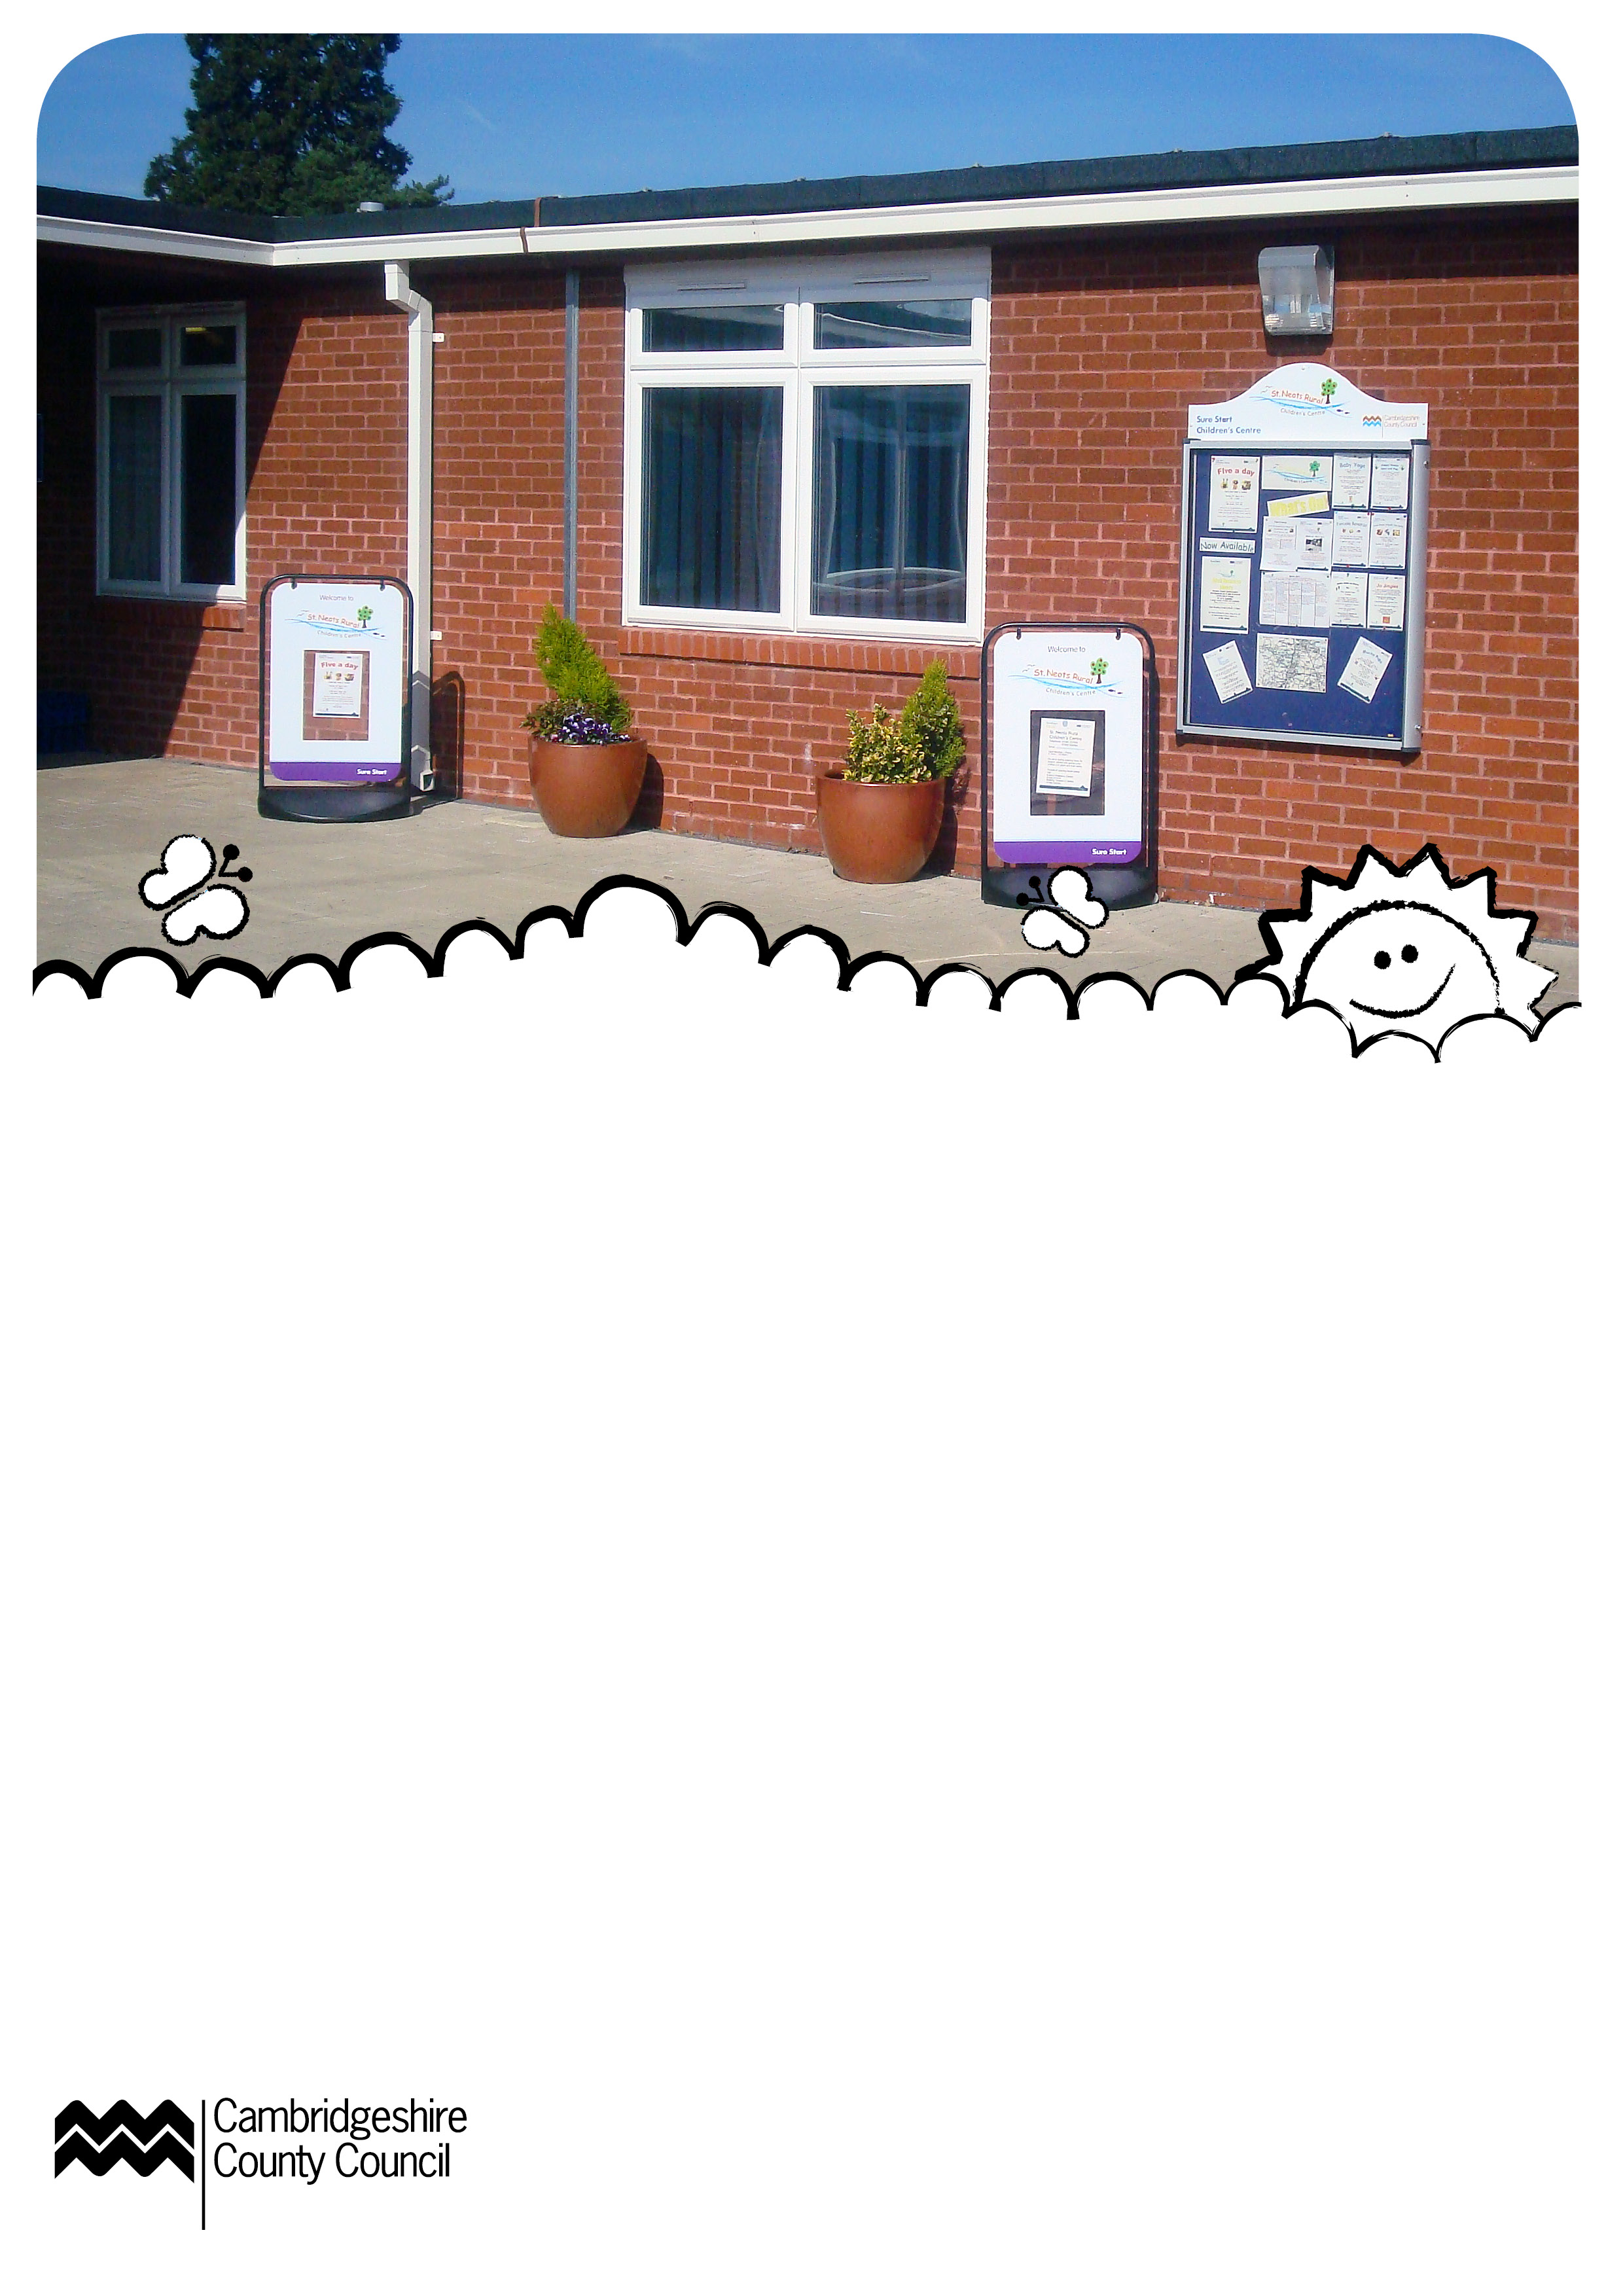

Whats’s On
September 2012
Opening Times
Monday – Friday
8.45am – 12.45pm
What is a Children’s Centre?
Children’s Centres support all families with children under five. We offer easier access to health and family support, helping with finding jobs, and training, stay and play sessions and activities and information about local childcare and early education.
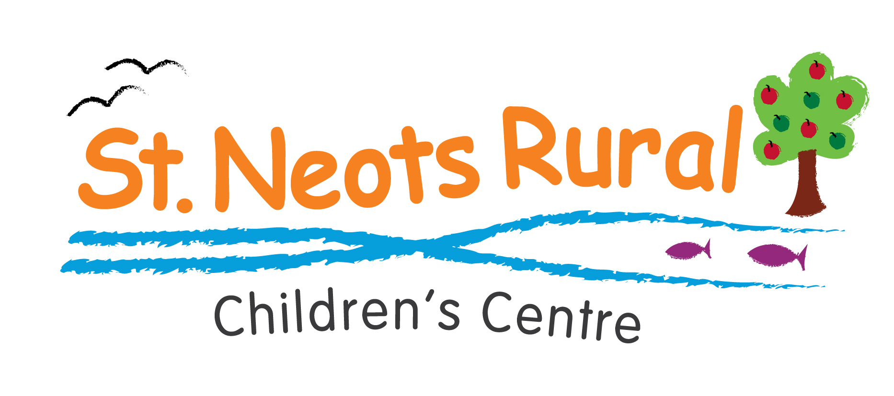
Monday
Happy Hands
10.00-11.30am
Weekly stay and play. Open to children up to 5 years old.
Little Paxton Village Hall
Stay and Play
9.30-10.30am
10 September
Drop in and play. Open to children
up to 5 years old.
Great Gransden,
Reading Rooms
Tuesday
Play-A-Weigh
1.30-3.00pm
11 & 25 September
Baby weighing and play sessions.
Buckden Millennium Hall, Burberry Road, Buckden
Wednesday
Busy Bees
10.00-11.30am
Weekly stay and play. Open to children up to 5 years old.
Great Staughton Village Hall, The Green

Little Starlings
1.30-3.00pm
Drop in for craft activities, singing, stories and play. Open to children up to 5 years old.
Roundhouse School,
Loves Farm
Sing, Sign & Rhyme
11.30 – 12.30pm

Re-starts 5 September
Sing nursery rhymes and learn everyday signs. For all children under 5. Term time only.
St Neots Football Club
Thursday
Shake Rattle and Rhyme
10.00-11.00am
Weekly music, movement and rhyme time sessions for children aged 2 – up to 5 years.
Kimbolton Mandeville Hall, Thrapston Road
Child Safety Fun Day!
1.00-2.30pm
6 September
Come along and learn more about child safety. There will be an interactive visit from emergency services, craft activities and games. Why not bring a picnic! Open to the whole family.
St. Neots Riverside Park (behind the Ambience Café)

Friday
Play-A-Weigh
9.30-11.00am
7 & 21 September
Baby weighing and play sessions.
Little Paxton Primary School
Saturday
Men Behaving Dadly
10.30 – 12.00 noon
1 September
Stay and play for all male carers and their children up to 5 years old. Come and join in with craft activities and outdoor play.
Butterfly Children’s Centre,
Winhills Primary School
Paediatric First Aid
For Male Carers
9.30 – 11.30am
22 September
An adult course to gain an attendance certificate in emergency life support for
infants and children.
Booking essential.
St Neots Football Club,
Gregory Suite

Future Events
JobCentrePlus Drop-In
9.00–10.45am
Monday 8 Ocotober
Drop-in session providing advice on applying for jobs and benefits.
The Eatons Children’s Centre, Bushmead School
Luminus Housing Advice
10.00-11.00am
Thursday 18 October
Drop in for advice and information on housing.
Butterfly Children’s Centre, Winhills School
Paediatric First Aid
10.00 – 12.00 noon
Tuesday 30 October
An adult course to gain an attendance certificate in emergency life support for
infants and children.
Booking essential.
Buckden Millennium Centre



Are you registered correctly?
Please remember to update your registration details with the centre if you move house, change telephone number, have a baby or add carers to your family.

All sessions are for children under 5 unless stated.
Contact
For more information contact:
St Neots Rural Children’s Centre
Little Paxton Primary School, Gordon Road, Little Paxton, St Neots, Cambs, PE19 6NG
For more information or to book an activity call 01480 357540
Email: stneotsruralchildrenscentre@cambridgeshire.gov.uk


