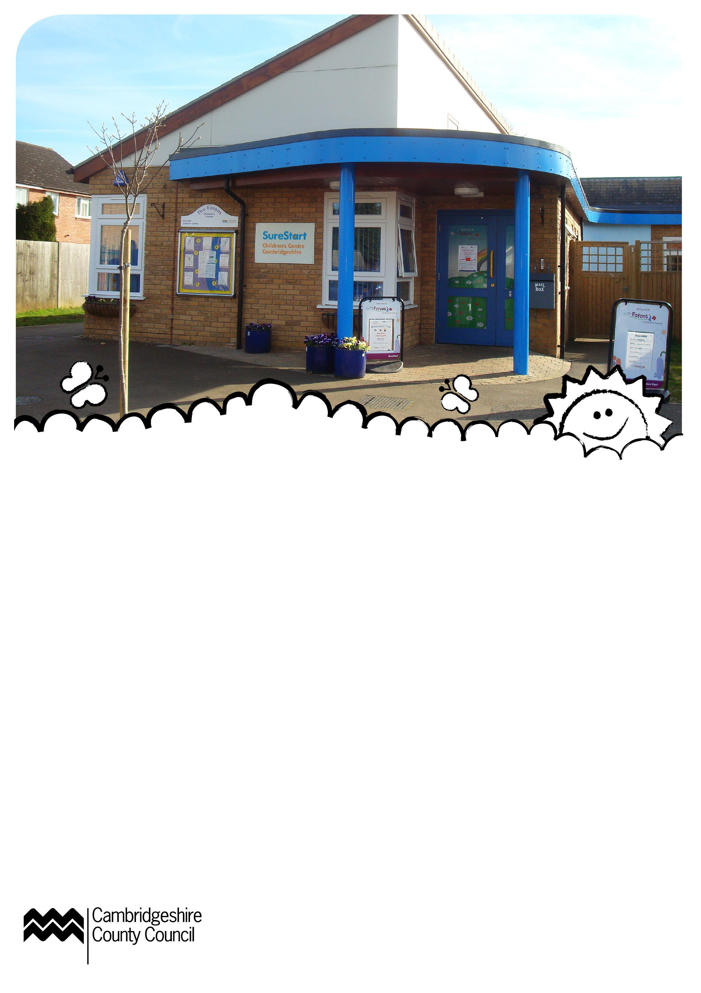
What’s On
September 2012
Opening times
Monday – Thursday 8.45am - 4.30pm
Friday 8.45am - 1.00pm
What is a Children’s Centre?
Children’s Centres support all families with children under five. We offer easier access to health and family support, help with finding jobs, and training, drop-in sessions and activities and information about local childcare and early education.


Monday

Childminder Group
9.15–11.45am
From 10 September
For childminders and their
child-minded children.
Shake and Wiggle
9.30–10.30am
Drop-in music and dance session followed by singing and story. Spaces are limited.
Young Parents Group
1.00–3.00pm
Drop-in group for parents 23
and under with their children up to the age of 5.
JobCentrePlus Drop-In
9.00–10.45am
10 September
Drop-in session providing advice on applying for jobs and benefits.
Baby Massage
1.15-2.15pm
Starts 10 September
For pre-crawling babies.
Booking essential
Tuesday
Mucky Pups
9.30–11.30am
Arts, crafts and messy play. Open to children up to age 5.
Singasaurus
3.30-4.15pm
Starts 4 September
Held fortnightly – a singing and rhyme time drop-in group for 0 – under 5’s.

Confidence for Work
1.45-4.00pm
11 September
Join our free workshop to learn the skills to feel confident at interviews and write a better CV. Limited crèche spaces available.
Booking essential.
Luminus Housing
11.00–12noon
18 September
Drop-in for advice and
information on housing.
ESOL
1.00-3.00pm
Starts 18 September
Eleven week course for speakers of others languages learning basic listening and speaking skills. Limited crèche spaces.
Booking essential.
Speech and Language Drop-in
9.30–12noon
25 September
A qualified speech and language therapist is available for advice if you have any questions about your child’s speech and communication.

Wednesday
Bouncers
9.30–11.00am
Indoor physical play session
and sing-a-long. For walking - under 5’s. Spaces are limited.
Stay and Play
2.00–4.00pm
Incorporating Multiple Birth Group. Just drop in and play!
Thursday
Bumps and Babes
10.00–12noon
A drop-in group for expectant mums, dads and pre-walking babies run by NCT volunteers.
BRAS
12.00–1.00pm
Weekly drop-in for breast-feeding reassurance and support.
Stay and Play
1.30–3.30pm
Drop-in and play.
Shake & Wiggle
3.30–4.30pm
Drop-in music and dance group. Suitable for walking – under 5. Spaces are limited.
Baby Essentials
1.00 – 3.00pm
Starting 27 September
Six themed sessions for first time parents.
Booking essential.
Friday
Stay and Play
8.45–12noon
Drop-in and play.
Parents Forum
11.00am-12.30pm
Friday 7 September
Calling all parents/carers that use the centre – please feel free to join us to share any ideas/ opinions you may have about St. Neots Children’s Centres.
La Lèche League
10.00am-12noon
21 September
Drop-in and join a monthly meeting for breast-feeding support, encouragement
and information.
ZooLab
9.15-10.15am
28 September
Come along to our one off mini beast workshops. You will be able to meet a selection of tropical animals and learn facts about them.
Saturday
Men Behaving Dadly
10.30–12.00noon
1 September
Stay and play for all male
carers and their children up
to 5 years old. Phone 01480 358350 for more information.
At Butterfly Children’s Centre, Winhills Primary School.
Coming Soon
JobCentre Plus Drop-in
9.00-10.45am
Monday 8 October
Drop-in session providing advice on applying for jobs and benefits.
Speech and
Language Advice
9.30–12noon
Tuesday 9 October
Drop-in with a qualified speech and language therapist.
International Event
2.00-4.00pm
Thursday 18 October
Come and join in our fun interactive session with craft activities, this month’s country is Ireland.
Booking advisable
Contact
The Eatons Children’s Centre
Bushmead School, Bushmead Road, Eaton Socon, St. Neots, PE19 8BT. For more information or to book an activity call
01480 358340 or email:
eatonsoconchildrenscentre
@cambridgeshire.gov.uk
All sessions are for children under 5 unless stated.

